Chapter 10, Solution 8.

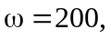

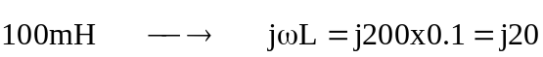

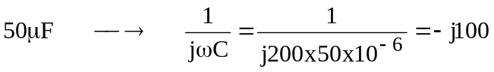

The frequency-domain version of the circuit is shown below.

0.1 V_{o}

40
V₁ I_{o} V₂

+ -j100
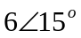 20 V_{o} j20
-

At node 1,

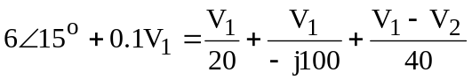
or (1)

At node 2,

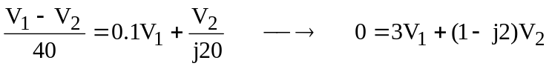 (2)
From (1) and (2),

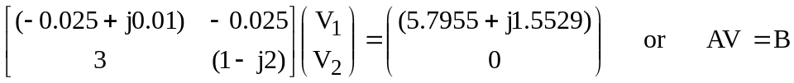

Using MATLAB,

V = inv(A)*B

leads to

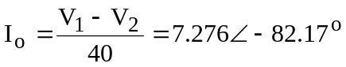
Thus,
